Walsh Memorial CE (VC) Infant School

Anti-Bullying Policy

Summer 2022

Review Summer 2023

We believe that Walsh Memorial C of E (VC) Infant School should provide a secure environment in which every child can flourish as a learner, grow in self-confidence and learn tolerance and mutual respect. Our children will learn to take responsibility for themselves and others. We aim to ensure that all children feel safe from bullying and are confident to seek support from adults should they feel unsafe.

We will not tolerate bullying in any form and will take all necessary steps to stop it. Bullying happens when a person is subjected to targeted abuse over a period of time by another person or persons. Bullying can involve physical or verbal attacks, name calling, malicious gossip, damaging or stealing the property of the victim or coercing the victim into acts which they do not wish to do. We are aware that children are becoming victim to electronic forms of bullying, cyber bullying, at very young ages and this too will not be tolerated in any circumstances.

All members of staff will act in accordance with this policy if bullying is observed or reported. They will respond not just to the bully but to the child/children being bullied. Research suggests that both bully and bullied are victims. The watchfulness of individual all staff, inside and outside the classroom is one kind of preventive activity as well as on-going education about appropriate behaviour and bullying.

Aims and objectives

- To support a school culture where being differences, being unique and diversity are accepted and celebrated.
- To build an emotionally literate school where telling can be done without fear of repercussions and all children feel safe.
- To raise the awareness of children, parents/carers, governors and whole school staff about bullying behaviour
- To provide strategies for preventing and dealing with bullying promptly and consistently
- To provide understanding and support for both victims and those who are perpetrators of bullying.

Definition of bullying
In our school council meeting, our children defined ‘bullying’ as ‘A bully is someone who hurts, frightens or upsets another person on purpose.’ Bullying is when someone keeps meaning to hurt someone by doing or saying things; to have the power over another person.’ STOP – Several, Times, On, Purpose

We define bullying as;

- deliberately hurtful or threatening behaviour
- premeditated and usually forms a pattern of behaviour rather than an isolated incident
- behaviour that involves dominance or exclusion of one child by another, or group of others

The following poster will be displayed around school:

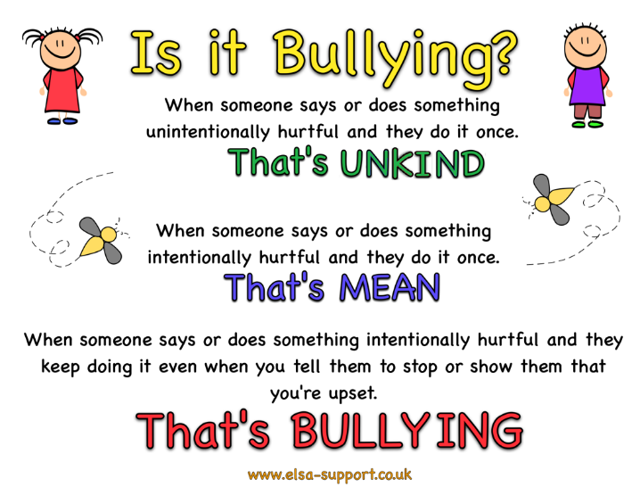
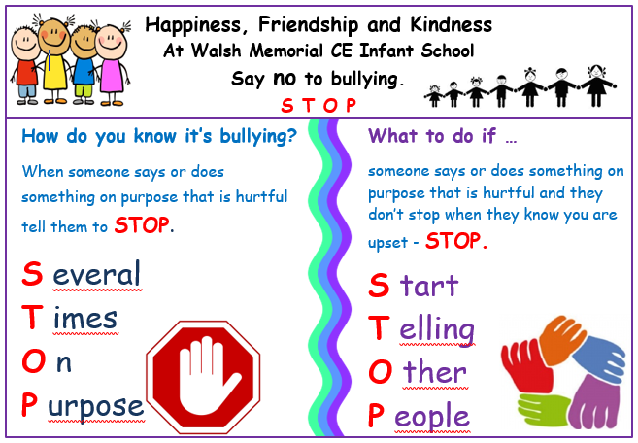

Our children helped to choose the words to explain each part of the ‘Is it bullying?’ poster, therefore having ownership and understanding of the stages.

Bullying may be:

- Physical (pushing, hitting, kicking, pinching, any form of violence, threats)

- Verbal (name-calling, persistent teasing, sarcasm, spreading rumours,)

- Emotional (tormenting, threatening, ridicule, humiliation, exclusion from groups or activities)

- Cyber (via internet chat sites or mobile phones)

- Racist (racial taunts, graffiti, gestures because they are different from themselves)

- Sexual (unwanted physical contact, abusive comments which may have homophobic / sexist messages)

- Unkindness verbal / physical /emotional / cyber due to Special Educational Needs (SEN) differences

Identifying bullying

Children who are being bullied may not always be prepared to tell someone. It is important therefore that members of staff are observant and alert for signs of bullying, which might include:

- unwillingness to come to school
- withdrawn, isolated behaviour
- complaining about missing possessions
- refusal to talk about the problem • being easily distressed
- damaged or incomplete work

When a disclosure is made, it will always be listened to and carefully investigated.

Preventing bullying

We will endeavour to:

- ensure that all children know who to speak to if they have concerns that they or some-one else is being bullied
- look for signs of bullying and act promptly and firmly involving parents / carers where appropriate
- raise children’s awareness of what bullying behaviour actually is
- promote themes such as friendship, conflict, power and trust, through circle time, social skills, assemblies and throughout all lessons where possible
- use drama, scenarios and role play to explore and prevent bullying behaviour
- teach children to be assertive and to resolve conflict constructively
- encourage children to tell someone – a friend, class teacher, member of staff, parent – if they are being bullied or made unhappy we remind them of our ‘ STOP poster and ‘Is it bullying?’ poster
- encourage parents to contact the class teacher immediately if they are worried that their child may be being bullied – if this does not resolve the bullying then to contact the Headteacher or Deputy Headteacher
- ensure careful supervision, including engaging physical activities over play times and be alert to bullying behaviour
- ensure staff communicate possible bullying to relevant colleagues
- provide a range of lunchtime activities - both quiet and active, and games so vulnerable children may choose to join, giving them the opportunity to discover they share similar interests with other children and thereby developing their social strengths to feel more comfortable outside
- provide books and literature in main and class libraries which support good behaviours and inclusion of everyone
- ensure that there is regular staff training to implement a range of strategies in responding to bullying behaviours, so there is consistency in the anti-bullying message and approaches.
- ensure that children, staff and other adults follow our school values and model good social behaviours across the school community
- demonstrate that bullying behaviour will not be condoned or tolerated and that all incidents will be taken very seriously

Busy Bees and play leaders

Our Year 2 children have the opportunity to be a ‘Busy Bee’ helper. Busy Bee helpers support the children in the playground. They are a ‘friend to all’ who might help children in the following ways:
- encourage children join in games with others
- check buddy bus stop and encourage children to join in games where appropriate
- help others find solutions to conflict and rivalries and suggest other ideas when negotiating problems between friends i.e. taking turns
- support others to manage conflict
- model expected great behaviour
- help children is they hurt themselves and make sure they go safely to an adult
They will seek support from an adult in the playground if necessary. During ‘Busy Bee Training’ they learn how to talk to fulfil their role.

Play leaders help support playground games, and are trained to ensure it is fair and everyone is included.

Dealing with bullying

Where behaviour is suspected as being bullying, this will be reported to a designated safeguarding lead who will ensure the allegation is investigated fully by the appropriate member of staff, usually the class teacher. The actions may include:

- Interviewing the victim and bully separately

- Reassuring the child that s/he has done the right thing by reporting the situation.
- Victims of bullying often feel powerless and vulnerable. They may end up believing that they deserve to be bullied. Everything will be done to help re-establish the victim’s self-esteem and self-confidence.

- Speaking to the bully and identifying the reasons why s/he has acted in the way s/he has. The bully will be helped to recognise his/her unsociable behaviour and given support and counselling to modify that behaviour. The victim will also be given support to become more assertive and thereby less vulnerable to bullying.

- On some occasions it may be possible to sit victim and bully down together to discuss their feelings and the reasons why the situation has developed. The problem could then be resolved amicably and/or a compromise reached. On other occasions the bully will be told firmly to stop his/her antisocial behaviour immediately and to stay away from the victim.

- The parents of both parties should be contacted and informed should the school have reason to believe that bullying is taking place.

- Where parents have raised concerns regarding possible bullying, they will be invited into the school to discuss the matter and upon investigation any necessary action as described above will be taken.

- Follow up meetings with the victim and bully will be arranged to find out whether the solution has been effective or not, and the situation will be monitored.

- A written record will be made of every allegation of bullying. The report will include who was involved, where and when the incident occurred, what happened, what action was taken, whether the parents were informed and how the incident was followed up. These are kept on CPOMS.

Proven bullying could result in one or more of the following sanctions:

- meeting with the Headteacher or Deputy Headteacher which may also involve the parents / carers of both children
- writing an explanation or apology for the incident
- withdrawal of break or lunch time privileges
- removal from the class to work on an in-school exclusion
- fixed term exclusion
- permanent exclusion

Promoting an anti-bullying ethos

At Walsh Memorial C of E (VC) Infant School and through our PSHE curriculum particularly children learn:

- to identify and recognise their feelings
- about working well together
- what makes a good friend and how to be a good friend
- anti- bullying and about trusted adults to talk to
- who and what helps us keep safe and how we can look after each other

Social skills sessions and circle time will be used to explore issues around bullying including:

- What is bullying?
- What causes people to bully each other?
- How does it feel to be bullied or to bully?
- What are the effects of bullying behaviour?
- What would our school be like if bullying was acceptable?
- Why will we try not to bully each other?
- What can we do to stop bullying?

We always support National Anti-bullying week in November and during this term our PSHE theme is ‘What is Bullying’ in Year 2 and Being Special and Working as a Team in Year 1. EYFS focus on learning about feelings and specialness and how to be a good friend.

Advice for children who are being bullied

- Be firm and clear – look them in the eye and tell them to stop
- Get away from the situation as quickly as possible
- Tell a teacher or friend what has happened - don’t suffer in silence
- Tell your family
- Keep on speaking up until someone listens
- Don’t blame yourself for what has happened
- Advice for children who observe bullying
- Don’t allow someone to be deliberately left out of a group
- Don’t smile or laugh when someone is being bullied
- Tell a member of staff what is happening
- Encourage the victim to join in or play with you or your friends
- Tell the bully to stop what they are doing
- Show the bully that you disapprove of his/her actions
- Never support a bully or be tempted by a bully to do what s/he is doing

This policy links to the following school policies:

Positive Behaviour
Inclusion
Health Safety and Welfare
Equality and Diversity

